Enrolment Form 2018 | 

Welcome to the School of Business Ltd Trading As Exercise Academy!
Please read the instructions below carefully before you complete this enrolment form.
INSTRUCTIONS
The purpose of this enrolment form is to obtain from you the information we need to enrol you into a qualification at the School of Business Ltd. We also need to collect information from you which is required by the Ministry of Education, Tertiary Education Commission and other Government agencies for statistical and administrative reasons. Please fill in the form properly by:
- Completing all sections of the form.
- Printing your answers clearly in pen, or ticking the box that applies for multi-choice questions.
- Signing the form.
- Attaching to the form additional documentation that is required for Ministry of Education funding purposes. A description of the required documentation is provided on page 6 of the form.

A QUALIFICATION
1 | Please write the name of the qualification you wish to enrol in for 2018: |  |  |  |  |  |  | Office Use
1 | Start Date for this period of enrolment:
1 | Planned Finish Date for this period of enrolment:
1 | Do you intend to study: |  |  | Part Time Full Time
2 | Have you studied at the School of Business before? |  |  | Yes No
2 | If you answered “yes”, what was your Student ID number?
3 | Please enter the name(s) of the courses you wish to enrol in 2017:
B PERSONAL DETAILS
4 | Print your full legal name: Family Name:  Given Name(s):
5 | Preferred first name:
6 | If you have previously studied under another name at our organisation or elsewhere (including school), what was that name?
7 | Preferred title: | Ms Mrs Miss Mr Other (Specify):
8 | Date of birth: | day month year |  |  | 9 | Gender: | Male Female
10 | If you have a National Student Number (also known as the “NSN”): |  |  |  | --
11 | Citizenship and Residency: |  | Please follow the flow chart below and tick the appropriate box(es). If you are not a New Zealand or Australian citizen you will have to specify your citizenship in the shaded box.  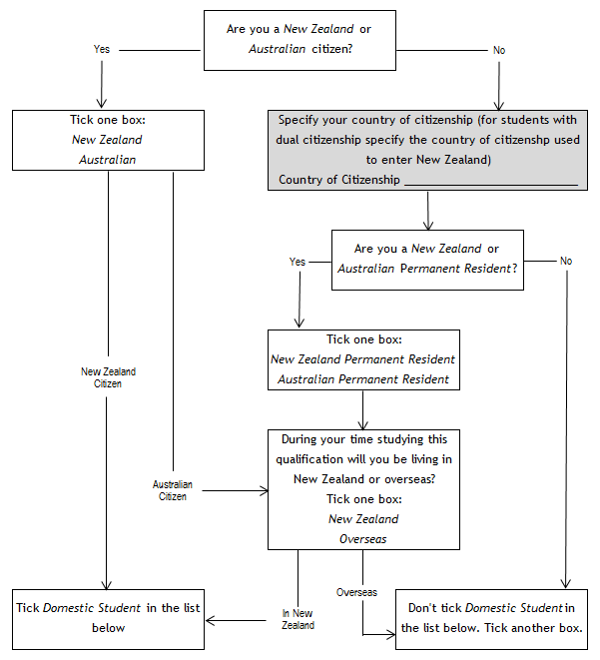
11 | You will need to supply evidence of residence status or citizenship |  | Now using the flow chart tick one of the boxes below:
11 |  |  | Domestic Student |  |  |  |  |  | 00
11 |  |  | NZAID Scholarship |  |  |  |  |  | 01
11 |  |  | International Fee-Paying Student (including people on current work visa) |  |  |  |  |  | 03
11 |  |  | Student on a recognised exchange scheme |  |  |  |  |  | 04
11 |  |  | Foreign Research Based Post-Graduate |  |  |  |  |  | 06
11 |  |  | Visiting military personnel, diplomatic staff or family, persons associated with Antarctic Programme |  |  |  |  |  | 08
11 |  |  | International On-Shore PhD student |  |  |  |  |  | 09
11 |  |  | International student who is ITO off-job trainee |  |  |  |  |  | 12
11 |  |  | Refugee or protected person whose application for residence is being processed or a person who has made a claim to be recognised as a refugee or protected person and holds a valid temporary visa |  |  |  |  |  | 13

12 | Ethnicity:  What ethnic group(s) do you belong to?  You may tick up to three boxes which apply to you. |  | NZ European/Pakeha 111 Filipino 411  New Zealand Māori 211 Cambodian 412  Samoan 311 Vietnamese 413  Cook Island Māori 321 Other Southeast Asian* 414  Tongan 331 Chinese 421  Niue 341 Indian 431  Tokelauan 351 Sri Lankan 441  Fijian 361 Japanese 442  Other Pacific Peoples* 371 Korean 443  British/Irish 121 Other Asian* 444  Dutch 122 Middle Eastern 511  Greek 123 Latin American 521  Polish 124 African 531  South Slav 125 Other* 611  Italian 126 Not Stated 999  German 127  Australian 128  Other European* 129  *Please specify if “Other Pacific Peoples”, “Other European”, “Other Southeast Asian”, "Other Asian" or "Other”:
13 | Iwi:  If you identified as New Zealand Māori in question 12, what is the name of your iwi (tribe or tribes) and rohe?  You may enter more than one iwi. If you do not know your iwi, please enter “Don't Know”. |  |  | Iwi:  Rohe (iwi home area):  Iwi:  Rohe (iwi home area):  Iwi:  Rohe (iwi home area): |  |  | Office Use
14 | Prior activity: | What was your MAIN activity or occupation in New Zealand at the 1st October preceding the start of this enrolment? You may tick only one box.  Secondary school student 01 Non-employed or beneficiary (excluding retired) 02  Wage or salary worker 03 Self-employed 04  University student 05 Polytechnic student 06  House-person or retired 08 Overseas (irrespective of occupation) 09  Private Training Establishment student 11 Wānanga student 12
15 | Disability (the completion of this section is not compulsory):  Do you live with the effects of significant injury, long term illness, or disability? The information you supply is confidential.  If “Yes”, how would you describe your impairment, disability, or long term medical condition: |  |  |  | Yes | No

C ACADEMIC INFORMATION
16 | Secondary School: | What was the name of the last secondary school you attended? State “overseas”, if applicable. |  |  |  | Office Use
16 | Secondary School: | What was your last year at secondary school?
16 | Secondary School: | What is the highest level of achievement you hold from a secondary school? Your highest achievement may be a “traditional” award such as School Certificate, or you may have achieved a number of credits or a National Certificate at a certain level on the National Qualifications Framework. Your NZQA Record of Achievement shows you how many credits you have. Tick only one box.
16 | Secondary School: | No formal secondary qualifications |  |  | 00
16 | Secondary School: | 14 or more credits at any level |  |  | 11
16 | Secondary School: | NCEA Level 1 or School Certificate |  |  | 12
16 | Secondary School: | NCEA Level 2 or 6th Form Certificate |  |  | 13
16 | Secondary School: | NCEA Level 3 or Bursary or Scholarship |  |  | 15
16 | Secondary School: | University Entrance# |  |  | 14
16 | Secondary School: | Overseas qualification (includes International Baccalaureate & Cambridge Exams)* |  |  | 09
16 | Secondary School: | Other* |  |  | 98
16 | Secondary School: | Not Known |  |  | 99
16 | Secondary School: | # From 2014 University Entrance includes NZEA level 3 and a number of other requirements. See the NZQA website for more details.
16 | Secondary School: | *Please specify if “Overseas qualification” or “Other”:
17 | Tertiary Study: | Will this be the first year you have ever enrolled in a University, Polytechnic, Institute of Technology, Private Training Establishment, or Wānanga either in New Zealand or overseas since leaving school? Do not include enrolments in STAR, community or hobby classes.  No Yes  If you answered “No”, please enter the name of the organisation you studied at and year of your first enrolment.  Name: Year
17 | Tertiary Study: | If you have completed one or more tertiary qualifications enter the name of the highest level qualification.
  Name: |  | Level (if known):
17 | Tertiary Study: | What year do you expect to complete the academic requirements necessary to graduate with your qualification?  Year
18 | English Language | Is English your first language? | Yes | No
19 | Literacy & Numeracy for Adults | Have you used the Literacy & Numeracy for Adults assessment tool? | Yes | No
19 | Literacy & Numeracy for Adults | What type of assessment(s) did you do? | Reading  Writing  Vocabulary  Numeracy

D DOCUMENTATION
20 | You must provide evidence of citizenship or permanent residency to qualify as a domestic student, and so be entitled to the Government tuition subsidy. This means you must produce one of the following:  - Birth certificate with place of birth stated as New Zealand, Cook Islands, Tokelau, or Niue.  - New Zealand passport.  - Australian passport.  - A statement of Whakapapa, including date of birth, countersigned by a kaumatua.  - Certificate of citizenship or letter of confirmation.  - Proof of New Zealand or Australian Permanent Residency.  International students must bring their passport with them when they enrol.  You can bring the original documentation to the enrolment desk, alternatively please provide a certified copy. This means a photocopy of your original document, signed as being a true and accurate copy by a Justice of the Peace (JP), Barrister or Solicitor, Notary Public, Court Register or Deputy Registrar, Member of Parliament, Land Transport New Zealamd, Public Trust, or local authority employee designated for this purpose. When a learner is in a remote community and unable to access a person listed in the Oaths and Declarations Act, a member of the New Zealand Police, school principal, minister of religion, or general practitioner is acceptable.
21 | Please list here all documents that you have attached to this enrolment form. Documents should be securely stapled to the back of the form.
E CONTACT DETAILS
22 | Address and contact details: | Permanent Address |  | Term Time Address (if different from permanent address)
22 | Address and contact details: | Post Code: |  | Post Code:
22 | Address and contact details: | Phone: ( ) | ( ) ( ) | Alternative Phone:
22 | Address and contact details: | Mobile: | ( ) | Email:
22 | Address and contact details: | Fax: | ( ) | Email:
22 | Address and contact details: | What is your postal address?  Permanent Address Term Time Address Other  If you ticked “Other” please write your postal address below.  Post Code:
22 | Next of Kin: | Name and Address: |  | Phone:
22 | Next of Kin: | Relationship to you: |  | Email:

USE OF INFORMATION AND PRIVACY STATEMENT
The School of Business Limited collects and stores information from this form to :
- Manage the business of School of Business Limited (including internal reporting, administrative processes and selection of scholarship and prize winners)
- Comply with the requirements of the Education Act 1989 and other legislation relating to maintenance of official records and accountability for public funding
- Supply information to government agencies and other organisations as set out below.
School of Business Limited may add your personal details (name, date of birth, gender and residency) to the National Student Index, which is managed by the Ministry of Education.
Supply of information to government agencies and other organisations
The School of Business Limited supplies data collected on your enrolment to government agencies, including:
- The Ministry of Education
- The New Zealand Qualifications Authority
- The Tertiary Education Commission
- The Ministry of Social Development (StudyLink): in relation to student loans and allowances)
- Immigration New Zealand (a branch of the Ministry of Business, Innovation and Employment): for those who are not New Zealand citizens or permanent residents.
Those agencies use the data supplied by tertiary education organisations to:
- Administer the tertiary education system, including allocating funding
- Develop policy advice for government
- Conduct statistical analysis and research.
The Ministry of Education may supply data collected on this form to Statistics New Zealand for the purposes of integrating data with data collected by other government agencies, subject to the provisions of the Statistics Act 1975. Integrated data is used for the production of official statistics, to inform policy advice to government and for research purposes.
When required by law, School of Business Limited releases information to government agencies such as the New Zealand Police, Department of Justice, Ministry of Social Development, and the Accident Compensation Corporation (ACC).
Information collected on this form may be supplied to other educational organisations for the purpose of verifying academic records.
In signing this enrolment form you authorise such disclosure on the understanding that School of Business Limited will observe the conditions governing the release of information, as set out in the Privacy Act 1993, the Education Act 1989 and other relevant legislation. You may see any information held about you and request that any errors in that information be amended or noted. To do so, contact the Enrolments Officer.

DECLARATION
Fees – In signing this enrolment form you undertake to pay all fees as they become due, and to meet any late fees and collection charges associated with debt recovery. School of Business Limited’s policy on withdrawal and refund of fees may be obtained from the Enrolments Officer.
Rules – In signing this enrolment form you undertake to comply with the published rules and policies of School of Business Limited with regard to attendance, academic integrity and progress, conduct and use of information systems.
Declaration – I declare that to the best of my knowledge all the information supplied on, and with, this enrolment form is true and complete, I agree to abide by the conditions described above, and I consent to the disclosure of personal information as described above.
_____________________________________________ ______/_____/______
Signature Date
► Please make sure that you have signed the enrolment form above ◄

Disclaimer: The School of Business Ltd reserves the right to cancel programmes / courses where enrolment numbers are insufficient to make delivery financially viable. In that event, the School of Business accepts no liability for personal expenses incurred by potential students. Any fees paid in this situation will be refunded in full.

