Wintec Biokinetic Clinic Training Program
 | Name of Client |  |  |  |  | James (lower back pain)
 | Name of the CEP Trainer |  |  |  |  | Alanah Parker
 |  |  |  |  |  |  |  |  |  |  | Training Day & Date
 | Client's Information |  |  |  |  | Exercises
 | Age |  |  | 27 |  |  |  | Reps | Weight |  | Intensity | BP Reading | HR/RPE
 | Gender |  |  | Male |  | Resting BP and Heart Rate
 | Height |  |  |  |  | Warm up: 5 mins on the bike
 | Weight |  |  |  |  | Mobilisation: Foam rolling glutes, hip flexors, TFL, Adductors |  | 7 passes | BW
 | BMI |  |  |  |  | Hamstring power band straight leg raise and cycling |  | 15 sec hold  10 cycles | RB
 |  |  |  |  |  | Kneeling lunge stretch with band distraction |  | 15-20 secs | RB
 | Target BMI |  |  |  |  | Cat camel |  |  | BW
 |  |  |  |  |  | QL flossing (lying on back with knees at 90˚ over a chair) |  | 7 passes | BW
 |  |  |  |  |  | Hip mobility drill (with dowel rod) |  | 5 x 15 secs | BW
 | Suggestions |  |  |  |  | Muscle conditioning:
 |  |  |  |  |  | Foundation exercise (with foam roller) |  | 10 x 5 sec hold | BW
 |  |  |  |  |  | Glute bridges progressing to cooks hip lift (ball in opposite hip flexor) |  | 2 x 10 | BW
 |  |  |  |  |  | Power band lateral walks |  | 2 x 10 | RB
 |  |  |  |  |  | Quadruped bracing (finding neutral, followed by arm and leg extension) |  | 5 x 10 secs each side | BW
 |  |  |  |  |  | Beginners curl ups |  | 2 x 10 | BW
 |  |  |  |  |  | Dead bugs |  | 2 x 10 (each side) | BW
 |  |  |  |  |  | Quadruped Swiss ball squeezes |  | 10 x 5 sec hold | BW
 |  |  |  |  |  | Parloff press |  | 1 x 10 (5secs on 5secs off) each side | TB
 |  |  |  |  |  | Prone holds on Swiss ball (on knees) progressing to stir the pot |  | 3 x 30 secs  Stir the pot 1x12 each direction | BW

Anterior shoulder/levator scapulae power band release
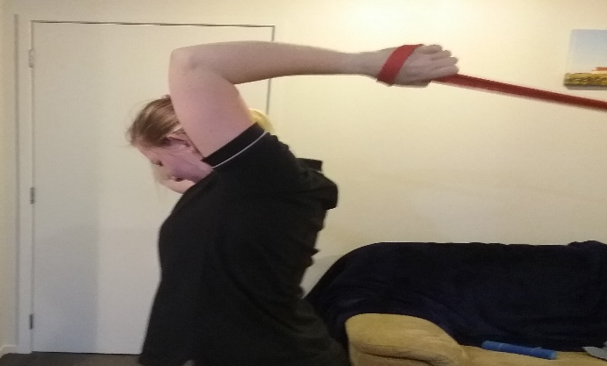
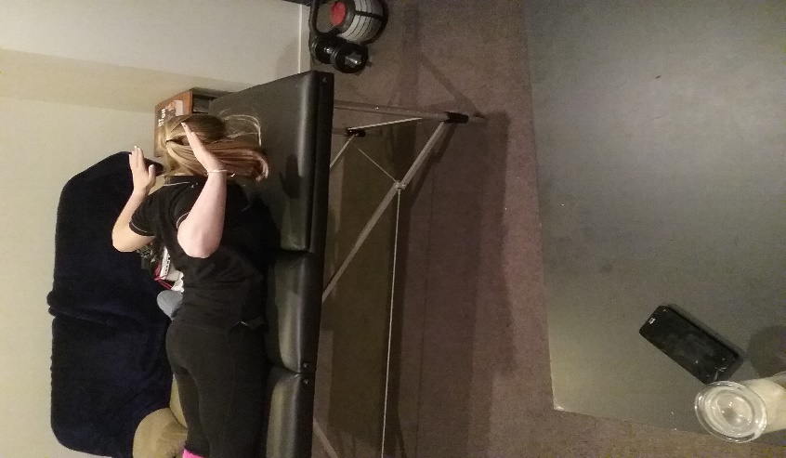
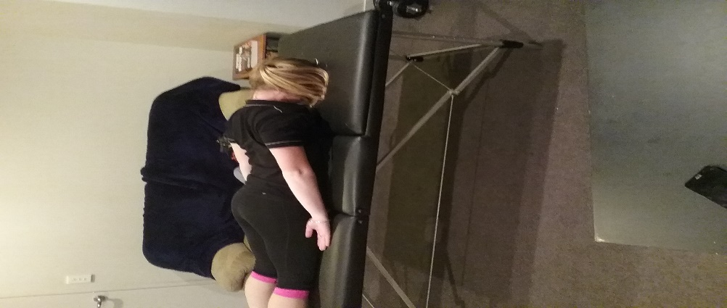
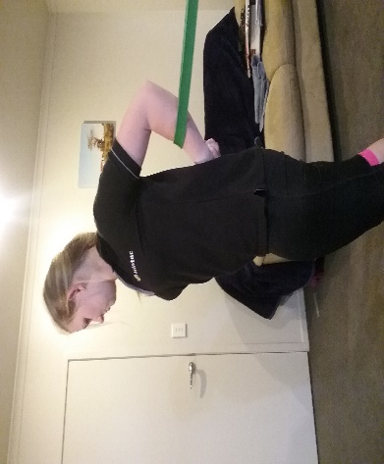
Straight arm band distraction internal rotation with band distraction prone scapula retraction with depression Y-W
